LAB ASSIGNMENT # 3

Q 1) Create Login to your application using Social login by using any of OAuth 2.0 service from Socail Networking service providers like Google, Facebook, Instagram, twitter, LinkedIn …. Etc.

Google Login :

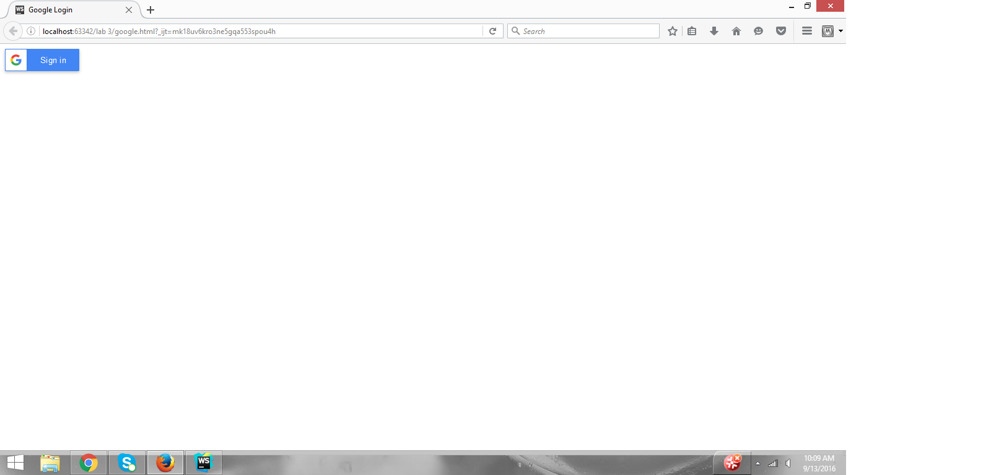

Google Login page :

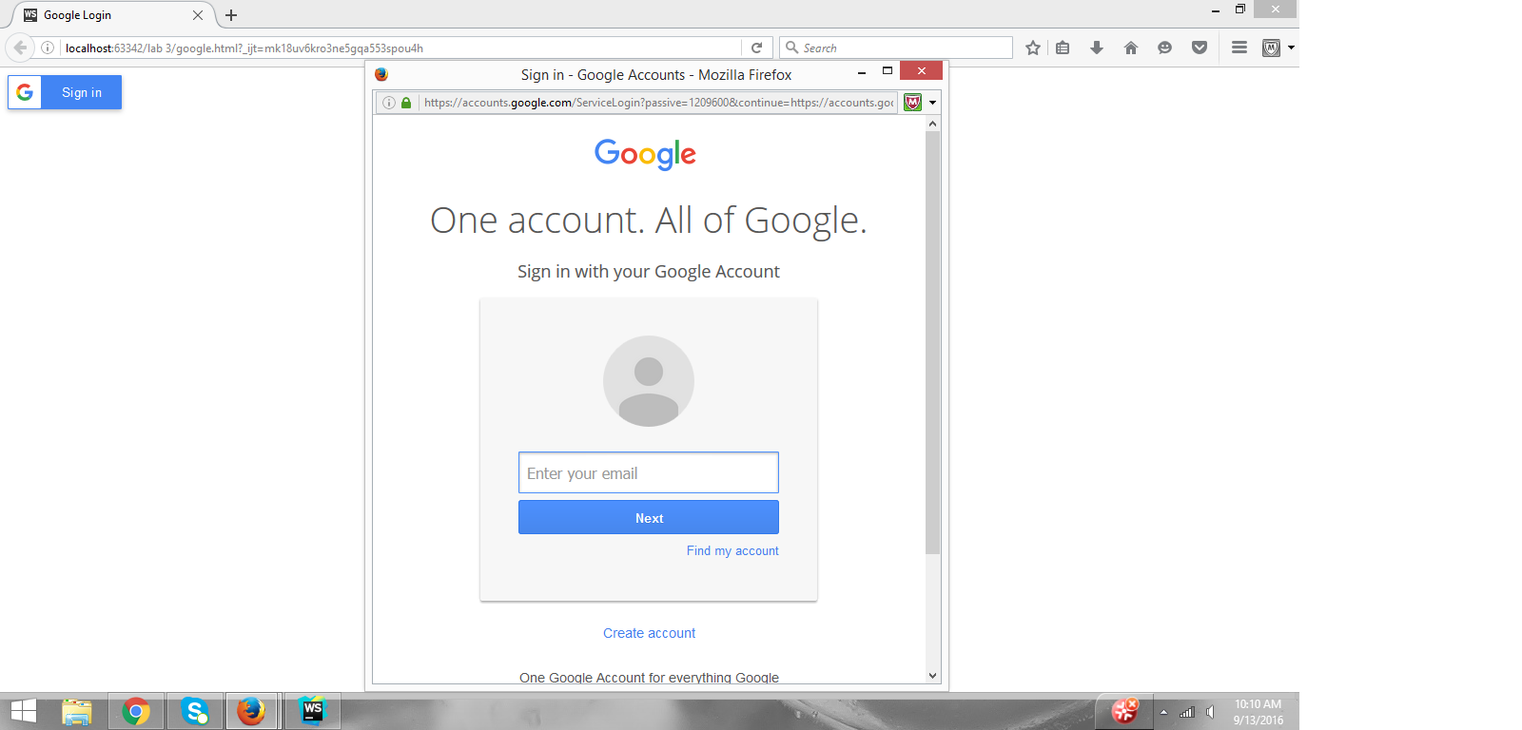

Facebook Login :

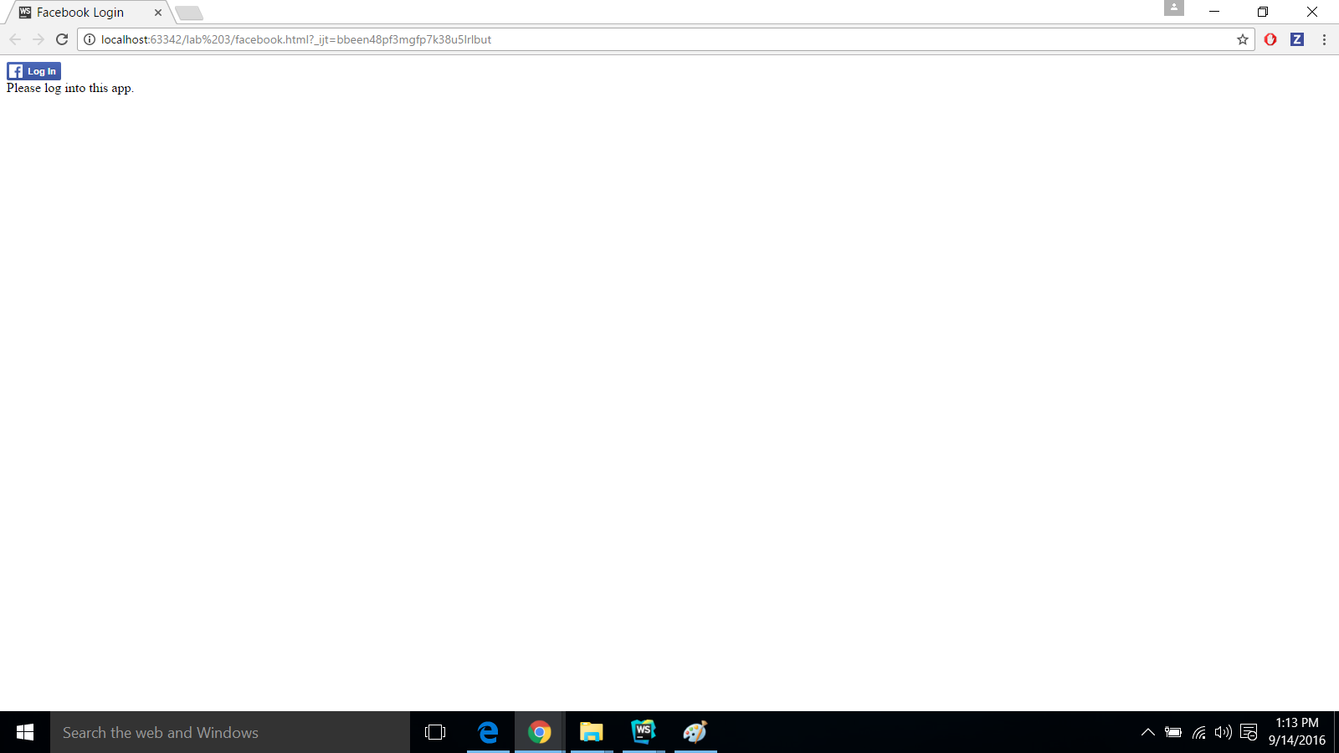

Facebook Login page :

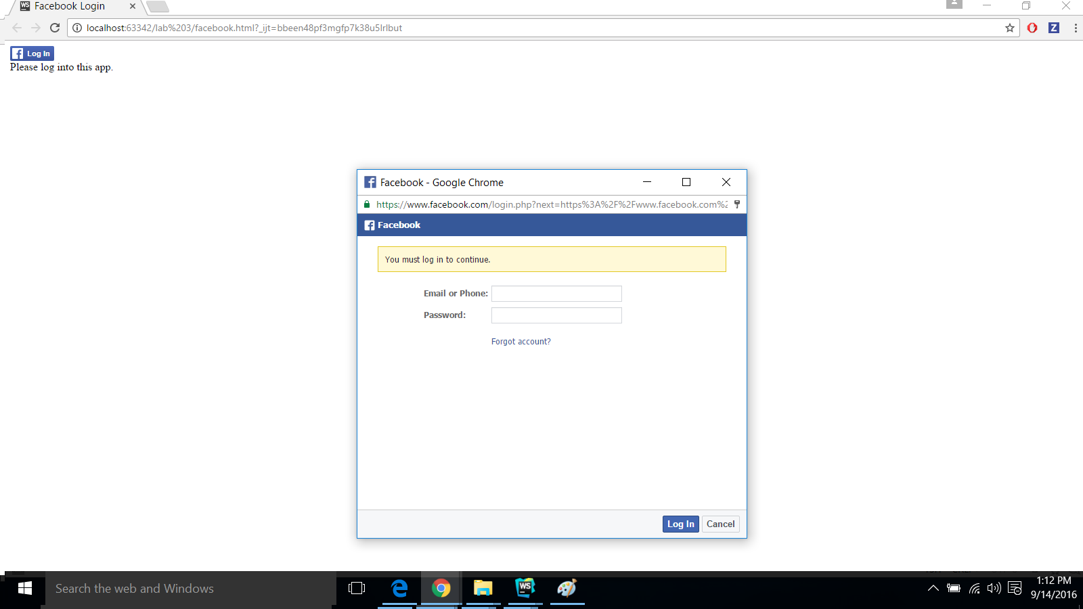

Q 2) Create a Mashup application using at least two Web services. One of them should be from list of knowledge services.